**SEMINAR 5**

data1<-read.csv("S5 Aprilie.csv", header=T)

> data1

Couple Husband Wife

1 1 59 53

2 2 21 22

3 3 33 36

4 4 78 74

5 5 70 64

6 6 33 35

7 7 68 67

8 8 32 28

9 9 54 41

10 10 52 44

qqnorm(data1$Husband-data1$Wife)

qqline(data1$Husband-data1$Wife)

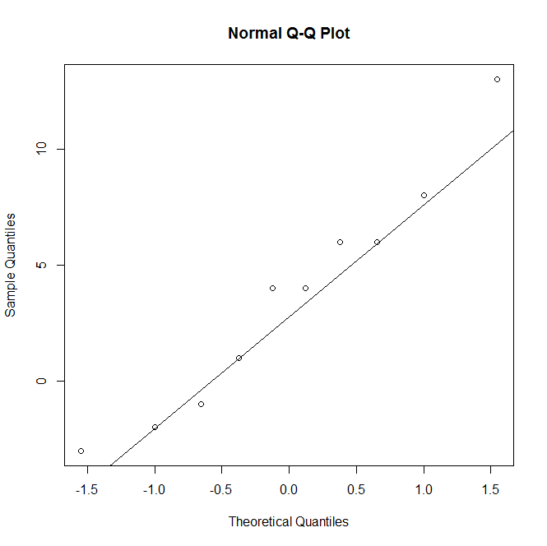

> t.test(data1$Husband,data1$Wife, paired=T)

Paired t-test

data: data1$Husband and data1$Wife

t = 2.2901, df = 9, p-value = 0.04777

alternative hypothesis: true difference in means is not equal to 0

95 percent confidence interval:

0.04394139 7.15605861

sample estimates:

mean of the differences

3.6

SEE DIFFERENCE!

> data2<-read.csv("S5 Aprilie_2.csv", header=T)

Age Gender

1 59 M

2 21 M

3 33 M

4 78 M

5 70 M

6 33 M

7 68 M

8 32 M

9 54 M

10 52 M

11 53 F

12 22 F

13 36 F

14 74 F

15 64 F

16 35 F

17 67 F

18 28 F

19 41 F

20 44 F

> t.test(data2$Age~data2$Gender, paired=T)

Paired t-test

data: data2$Age by data2$Gender

t = -2.2901, df = 9, p-value = 0.04777

alternative hypothesis: true difference in means is not equal to 0

95 percent confidence interval:

-7.15605861 -0.04394139

sample estimates:

mean of the differences

-3.6

n=length(data1$couple)

Age=c(data1$husband,data1$wife)

Age

[1] 59 21 33 78 70 33 68 32 54 52 53 22 36 74 64 35 67 28 41 44

Gender=rep(c("M","F"), c(10,10))

Gender

[1] "M" "M" "M" "M" "M" "M" "M" "M" "M" "M" "F" "F" "F" "F" "F" "F" "F" "F" "F"

[20] "F"

> df=data.frame(Age,Gender)

> df

Age Gender

1 59 M

2 21 M

3 33 M

4 78 M

5 70 M

6 33 M

7 68 M

8 32 M

9 54 M

10 52 M

11 53 F

12 22 F

13 36 F

14 74 F

15 64 F

16 35 F

17 67 F

18 28 F

19 41 F

20 44 F

>

EXEMPLUL 3

data1<-read.csv("C:/EC/language.csv", header=T)

> data1

Executive pretest posttest

1 1 32 34

2 2 31 31

3 3 20 35

4 4 10 16

5 5 30 33

6 6 33 36

7 7 22 24

8 8 25 28

9 9 32 26

10 10 20 26

11 11 30 36

12 12 20 26

13 13 24 27

14 14 24 24

15 15 31 32

16 16 30 31

17 17 15 15

18 18 32 34

19 19 23 26

20 20 23 26

qqnorm(data1$pretest-data1$posttest)

qqline(data1$pretest-data1$posttest)

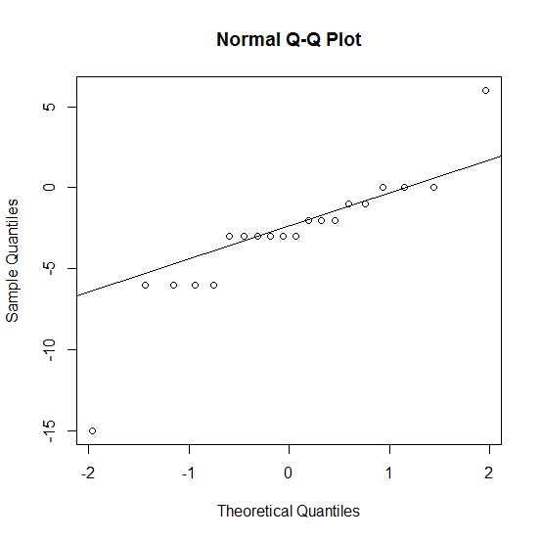

t.test(data1$posttest, data1$pretest, paired=T)

Paired t-test

data: data1$posttest and data1$pretest

t = 3.8649, df = 19, p-value = 0.001043

alternative hypothesis: true difference in means is not equal to 0

95 percent confidence interval:

1.146117 3.853883

sample estimates:

mean of the differences

2.5